1.Draw a simple network diagram showing how your smartphone connects to Instagram — include your device, Wi-Fi router, ISP, and Instagram's server, and label each part.
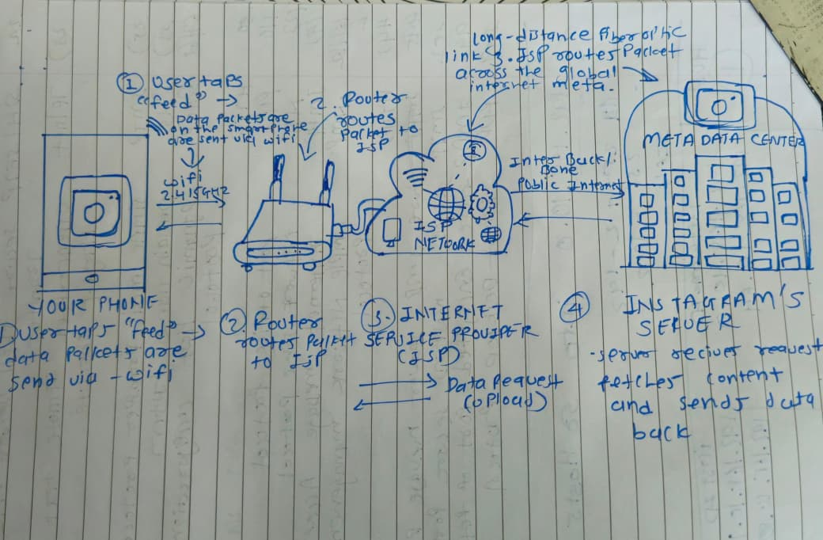
2.List the IP address of your device and your default gateway using the 'ipconfig' command (Windows) or 'ifconfig' (Linux/Mac), and explain what each means in 1-2 lines.
P Address
- Your device's ID: A unique numerical label assigned to your device on the local network.
- The purpose: It acts like a home mailing address so other devices know exactly where to send data.
Default Gateway
- Your network's exit: The IP address of the router that connects your local network to the outside world.
- The purpose: It serves as an access point or "gate" that routes your data out to the internet. [1]

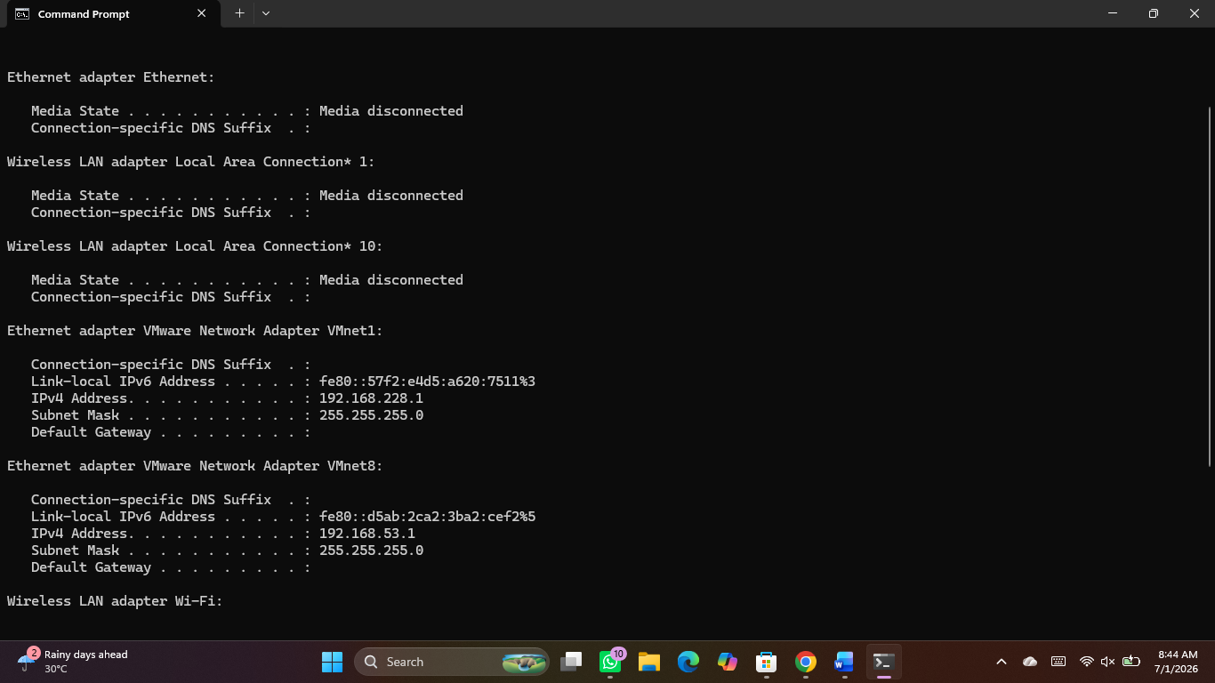

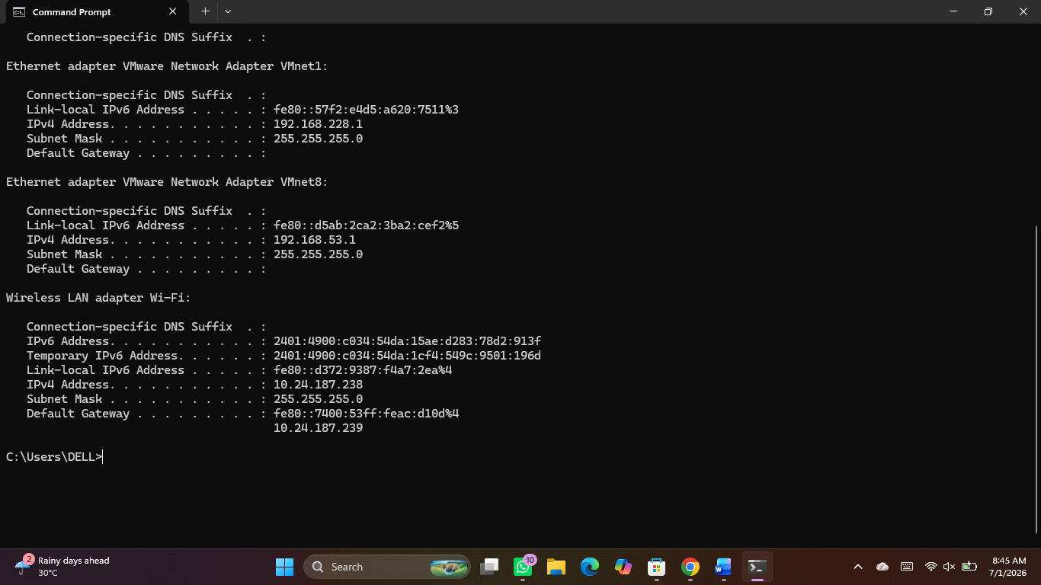
3.Simulate a Zomato food order journey by writing the steps/data packets that travel from your device to Zomato's server and back, mentioning protocols like HTTP, TCP/IP, and DNS wherever relevant. <br><br><em><strong>Hint:</strong> Think about what happens when you search for a restaurant and place an orde . </em>
Step 1: Translating the Address (DNS Lookup)
- What happens: You type "zomato.com" or open the app. Your device needs to find the server's numerical IP address.
- The Packets: Your device sends a DNS (Domain Name System) query packet to a DNS server.
- The Return: The DNS server replies with Zomato’s actual server IP address.
Step 2: Establishing the Connection (TCP Handshake)
- What happens: Your device opens a secure, reliable communication channel with Zomato's server.
- The Packets: A TCP (Transmission Control Protocol) three-way handshake occurs. Your device sends a SYN (synchronise) packet.
- The Return: Zomato’s server replies with a SYN-ACK packet. Your device responds with an ACK (acknowledge) packet to lock in the connection.
Step 3: Securing the Line (TLS Handshake)
- What happens: Because Zomato handles personal data and payments, the connection must be encrypted.
- The Packets: Over the established TCP lane, your device and the server trade TLS/SSL packets to agree on encryption keys.
- The Result: The connection upgrades from HTTP to HTTPS (Secure).
Step 4: Searching for Restaurants (HTTP Request & Data Routing)
- What happens: You search for "Pizza" in your location.
- The Packets: Your device sends an HTTPS GET request packet containing your search term and GPS coordinates.
- The Delivery: IP (Internet Protocol) packets wrap this data, stamping it with your source IP and Zomato's destination IP. Routers pass these packets across the internet.
- The Return: Zomato's server processes the request and sends back an HTTP 200 OK response packet loaded with restaurant names, ratings, and menu data.
Step 5: Placing the Order (Data Transmission)
- What happens: You add an item to your cart and hit "Place Order".
- The Packets: Your device sends an HTTPS POST packet. This payload contains your user ID, the selected items, your delivery address, and payment tokens.
- The Return: Zomato's server verifies the payment and routes a success response packet back. Your app screen updates to show "Order Confirmed" and initiates the live delivery tracking loop.

4.Use the 'ping' command to check the connection between your computer and www.spotify.com, then explain what the results mean for network troubleshooting.
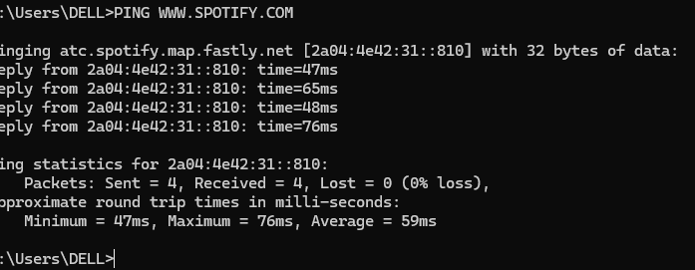
When you interpret the results of a ping test, you are evaluating three major elements of network health to locate where a connection is failing.
1. Reaching the Destination (Connectivity)
- What to look for: Look at whether you received replies or if you got errors like "Request timed out" or "Destination host unreachable."
- Troubleshooting meaning: Successful replies prove your device can physically talk to the server. If it times out, the server is either offline, blocking ping requests for security, or there is a break in the routing path between you and the server.
2. Packet Loss (Stability)
- What to look for: Look at the percentage of packets lost (e.g., 0% loss vs. 25% loss).
- Troubleshooting meaning: A healthy network must show 0% packet loss. Any loss higher than zero means data is being dropped along the way, which points to hardware issues, faulty network cables, bad Wi-Fi interference, or extreme network congestion.
3. Latency and Jitter (Speed and Consistency)
- What to look for: Look at the Round-Trip Time (RTT) values, specifically the Minimum, Maximum, and Average times in milliseconds (ms).
- Troubleshooting meaning: High average latency (e.g., above 150ms) means a very slow, lagging connection. A large gap between your Minimum and Maximum times (high jitter) means your network speed is unstable, which causes streaming apps to constantly freeze or buffer

